ASSIGNMENT -1
MODULE 1

COMPUTER NETWORKS
(PCCST501 )

How the Internet Delivers a Web Page
Website Chosen: Google (https://www.amazon.in)

1. Draw the TCP/IP Protocol Stack and Explain the Role of Each Layer
The TCP/IP protocol suite is a five-layer architecture that enables communication between devices over the Internet. Each layer performs a specific function and provides services to the layer above it.
APPLICATION LAYER

TRANSPORT LAYER

PHYSICAL LAYER

DATA LINK LAYER

PHYSICAL LAYER

Application Layer
The application layer provides services directly to users and application programs. It enables communication between processes running on different hosts. Protocols such as HTTP, SMTP, FTP, DNS, and SSH operate at this layer.

Transport Layer
The transport layer provides process-to-process communication. It receives messages from the application layer, divides them into segments, and ensures reliable data delivery using TCP or fast communication using UDP.

Network Layer
The network layer is responsible for host-to-host communication. It uses the Internet Protocol (IP) to assign logical addresses and route packets through routers until they reach the destination.
Data Link Layer The data-link layer transfers frames between adjacent devices on the same network. It adds MAC addresses and prepares data for transmission across the physical medium.
Physical Layer
The physical layer transmits bits as electrical, optical, or wireless signals over cables or air.
2. Explain the Role of DNS in Converting the Domain Name into an IP Address
When a user enters www.amazon.in into the browser, the browser cannot communicate using the domain name alone because communication on the Internet requires an IP address. The browser first contacts the Domain Name System (DNS). DNS is an application-layer protocol that translates a human-readable domain name into its corresponding IP address. After receiving the IP address, the browser knows the location of Google's web server and can establish communication with it. DNS acts as a distributed database that maps names to IP addresses, making it easier for users to access Internet resources without remembering numerical addresses.
www.amazon.in
│
▼
DNS Server
│
▼
142.250.xxx.xxx (Example IP Address)
3. Describe How HTTP Is Used to Request and Receive the Webpage
HTTP (HyperText Transfer Protocol) is the standard protocol used to access web pages. It follows the client-server model, where the browser acts as the client and the web server acts as the server.
The communication takes place as follows:
- The browser sends an HTTP request to Google's web server.
- The request usually uses the GET method to retrieve the required webpage.
- The server processes the request.
- The server sends an HTTP response containing the requested webpage.
- The browser receives the response and displays the webpage.
HTTP request contains:
- Request line
- Header lines
- Blank line
- Optional body
An HTTP response contains:
- Status line
- Header lines
- Blank line
- Body
4.Explain How TCP Provides Reliable Communication for HTTP TCP provides:
.Reliable delivery by ensuring that all data reaches the destination correctly.
  - Error control, which detects lost or damaged segments and retransmits them.
  - Flow control, which prevents the sender from transmitting data faster than the receiver can process it.
  - Congestion control, which reduces network congestion by controlling the transmission rate.
- Identify Whether the Application Follows Client–Server or Peer-to-Peer Architecture and Justify Your Answer
Google follows the Client–Server architecture.
In this architecture, the web browser acts as the client and Google's web server acts as the server. The client sends an HTTP request to the server, and the server processes the request and returns the requested webpage as an HTTP response.
This architecture is suitable because the web server stores the web pages and provides services to multiple clients simultaneously.
- Compare HTTP and FTP

HTTP | FTP
Used to access web pages on the World Wide Web. | Used to transfer files between computers.
Uses a single TCP connection for communication (persistent or nonpersistent). | Uses two TCP connections: one control connection and one data connection.
Mainly uses the GET and POST methods to request or send web resources. | Uses FTP commands such as RETR, STOR, LIST, and DELE for file operation
Primarily transfers HTML pages, images, CSS, and JavaScript files. | Transfers files of different formats between local and remote systems.
7.Explain How Cookies Improve User Experience with One Real-World Example
Cookies are small files stored in a user's browser that remember information such as login details, preferences, and shopping cart items. This makes websites faster and more personalized.
Example: On Amazon, cookies keep you logged in and remember the items in your shopping cart even after you close and reopen the website.
8. Flow Diagram Showing the Complete Communication
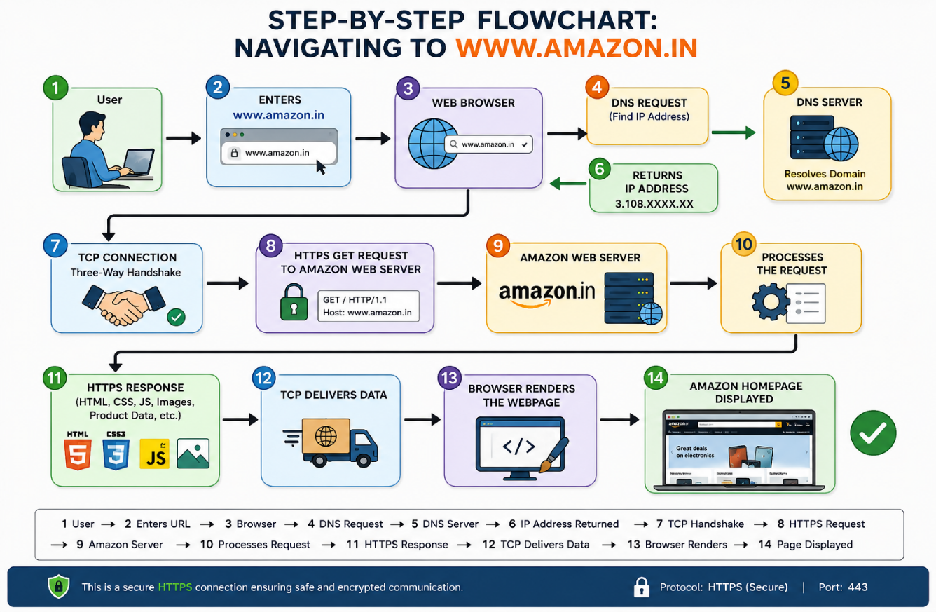

9.Write a brief conclusion (100–150 words) describing the importance of application-layer protocols in everyday Internet usage.
Application-layer protocols are essential for everyday Internet communication because they enable users to access various online services easily and efficiently. Protocols such as HTTP/HTTPS allow web browsing, SMTP and IMAP/POP3 support email communication, FTP enables file transfer, and DNS translates domain names into addresses. These protocols define standard rules that allow different devices and applications to communicate reliably over the Internet. They also improve security, efficiency, and user experience by ensuring accurate data exchange. Without application-layer protocols, common activities such as browsing websites, sending emails, streaming videos, or downloading files would not be possible. Overall, they form the foundation of modern Internet services and make global digital communication seamless and convenient.

